Lisbeth Gruwez dances Bob Dylan
Voetvolk / Lisbeth Gruwez & Maarten Van Cauwenberghe

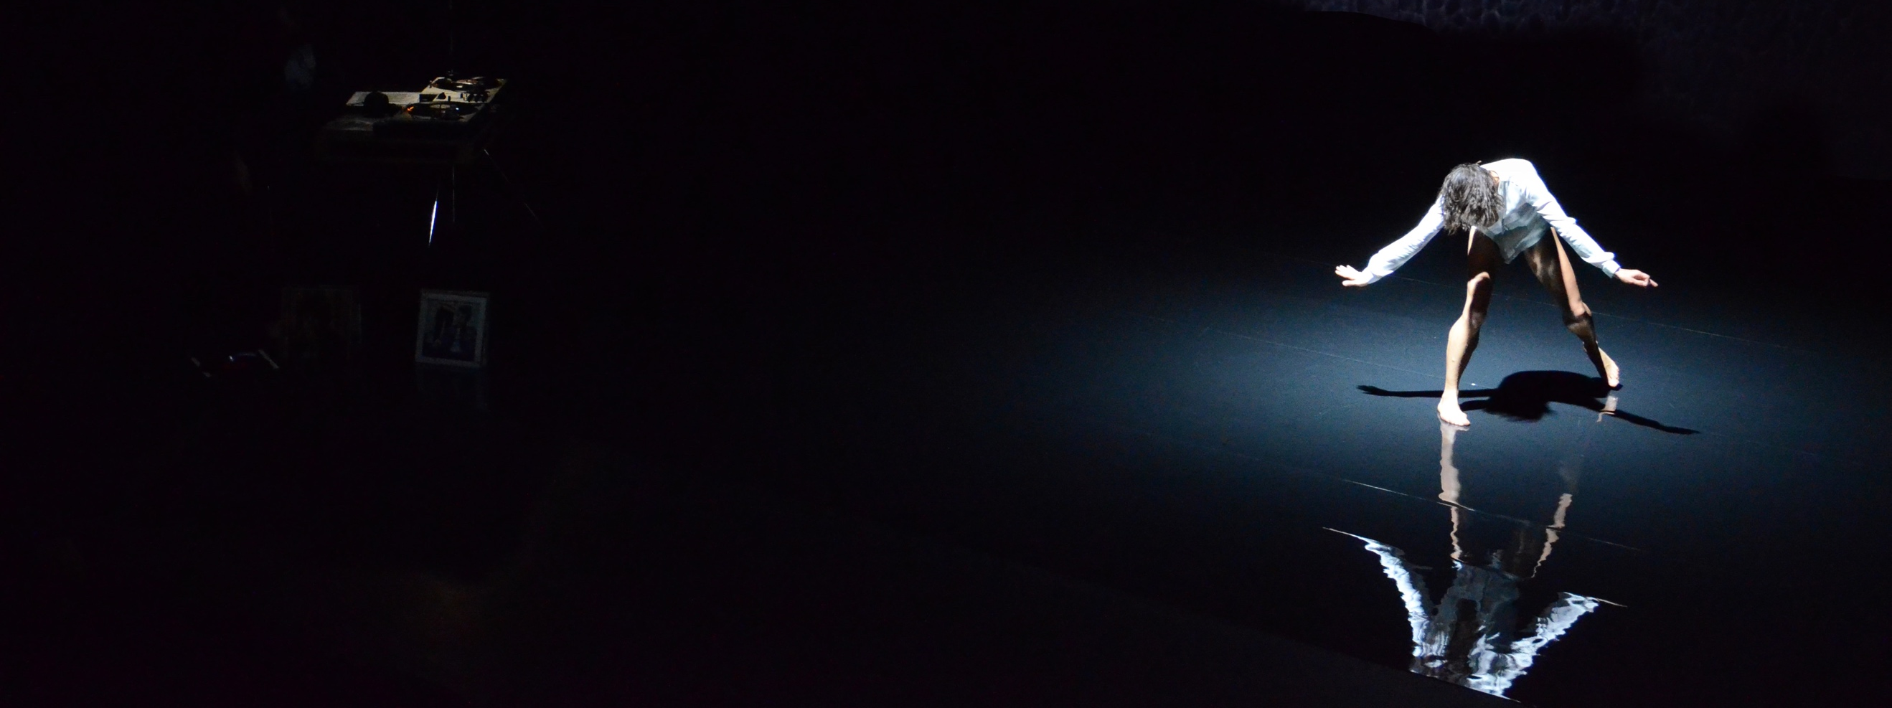

Lisbeth Gruwez dances Bob Dylan is an intimistic and pure dialogue between dancer/choreographer Lisbeth Gruwez and Bob Dylan songs from the sixties and seventies, carefully selected and played live on vinyl by Maarten Van Cauwenberghe, Gruwez’ partner-in-crime.

“Gruwez’s movements are in no way artificial. She becomes one with the songs of Dylan, completely absorbed in them and at times forgetting all about herself – with an intensity that enthrals the audience.”
(Delia Imboden, Berner Zeitung)

“She is neither illustrating the songs, nor simply doing her own thing with them; it’s as if she has turned the rasp and lilt of Dylan’s dancing voice inside out and has given it powerful, fluid gestures and an intense gaze; at times she even resembles Dylan.”
(Nicholas Minns & Caterina Albano, Writing about dance)

“Whether it’s the music that she connects with so deliciously or her performance presence that makes this dance a triumph, Gruwez is an unforgettable force to watch out for.”
(Josephine Leaks, DanceTabs)

“Lisbeth Gruwez dances Bob Dylan has to be seen as a moment of sharing through dance and music, mutually complementing each other in this particular alchemy that is the essence of the moment experienced as a community.”
(Quentin Guisgand, Infero Magazine)

TRAILER
https://vimeo.com/152875423
CREDITS FOR LISBETH GRUWEZ DANCES BOB DYLAN
CONCEPT AND PERFORMANCE Lisbeth Gruwez & Maarten Van Cauwenberghe
CHOREOGRAPHY Lisbeth Gruwez
MUSIC Bob Dylan
LIGHT DESIGN Harry Cole & Caroline Mathieu
TECHNICAL DIRECTOR Gilles Roosen
PRODUCTION MANAGER Anita Boels
COMMUNICATION Sam Ecker
SPECIAL THANKS TO Bart Meuleman, Café Costume & Marie Szersnovicz
PRODUCTION Voetvolk vzw
COPRODUCTION Royal Flemish Theatre, Rencontres Chorégraphiques Internationales de Seine-Saint-Denis, Ballet du Nord, TANDEM Arras-Douai, Les Brigittines
& Theater Im Pumpenhaus
SUPPORTED BY Arts Centre NONA, the Flemish Community
& the Flemish Community Commission
DIFFUSION Key Performance

CONTACT
Maarten Van Cauwenberghe
maarten@voetvolk.be
+32 495 52 12 88

www.voetvolk.be

